CHAPTER I
(Font size 12, Bold, Times New Roman and Centered)

(Two Blank Lines)
Introduction
1.1 Subtopic 1 (Font size 12, Bold, Times New Roman, two blank spaces after article no, and Left Indent)
[Times new roman 12pt normal font line spacing 1.5 lines, justified text pattern]
1.2 Subtopic 2 (Font size 12, Bold, Times New Roman, two blank spaces after article no, and Left Indent)
[Times new roman 12pt normal font line spacing 1.5 lines, justified text pattern]
1.3 Project report layout (Font size 12, Bold, Times New Roman, two blank spaces after article no, and Left Indent)
[Times new roman 12pt normal font line spacing 1.5 lines, justified text pattern]
Table 1. format (12pt)
Table Head | Table Column Head
 | Table column subhead | Subhead | Subhead
copy | More table copyª
We suggest that you use a text box to insert a graphic (which is ideally a 300 dpi TIFF or EPS file, with all fonts embedded) because, in an MSW document, this method is somewhat more stable than directly inserting a picture.
To have non-visible rules on your frame, use the MSWord “Format” pull-down menu, select Text Box > Colors and Lines to choose No Fill and No Line.

Fig. 1.1 Example of a figure caption format. (figure caption) [12 pt]

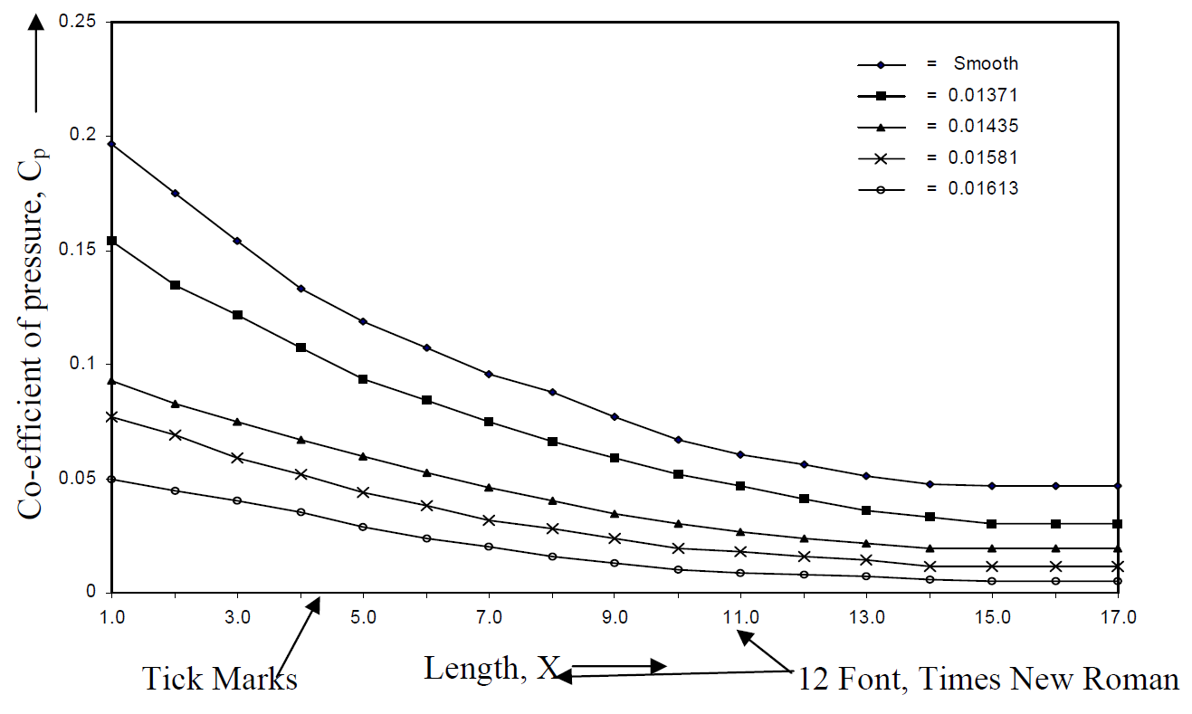

Fig. 1.2 Example of a graph caption format. (figure caption) [12 pt]

CHAPTER 2
(Font size 12, Bold, Times New Roman and Centered)

(Two Blank Lines)
Motivation/ Background Study
2.1 Subtopic 1(Font size 12, Bold, Times New Roman, two blank spaces after article no, and Left Indent)
[Times new roman 12pt normal font line spacing 1.5 lines, justified text pattern]
2.2 Subtopic 2 (Font size 12, Bold, Times New Roman, two blank spaces after article no, and Left Indent)
[Times new roman 12pt normal font line spacing 1.5 lines, justified text pattern]
2.2.1 Subtopic of subtopic 2 (Font size 12, Bold, Times New Roman, two blank spaces after article no, and Left Indent)
[Times new roman 12pt normal font line spacing 1.5 lines, justified text pattern]
2.2.2 Subtopic of subtopic 2 etc (Font size 12, Bold, Times New Roman, two blank spaces after article no, and Left Indent)
[Times new roman 12pt normal font line spacing 1.5 lines, justified text pattern]
2.3 Subtopic 3 [Times new roman 12pt normal font line spacing 1.5 lines, justified text pattern]
[Times new roman 12pt normal font line spacing 1.5 lines, justified text pattern]

CHAPTER 3
(Font size 12, Bold, Times New Roman and Centered)

(Two Blank Lines)
Methodology
3.1 Subtopic 1 (Font size 12, Bold, Times New Roman, two blank spaces after article no, and Left Indent)
[Times new roman 12pt normal font line spacing 1.5 lines, justified text pattern]
3.2 Subtopic 2 (Font size 12, Bold, Times New Roman, two blank spaces after article no, and Left Indent)
[Times new roman 12pt normal font line spacing 1.5 lines, justified text pattern]

3.2.1 Subtopic of subtopic 2 (Font size 12, Bold, Times New Roman, two blank spaces after article no, and Left Indent)
[Times new roman 12pt normal font line spacing 1.5 lines, justified text pattern]
3.2.2 Subtopic of subtopic 2 etc
[Times new roman 12pt normal font line spacing 1.5 lines, justified text pattern]

3.3 Subtopic 3 (Font size 12, Bold, Times New Roman, two blank spaces after article no, and Left Indent)
[Times new roman 12pt normal font line spacing 1.5 lines, justified text pattern]

CHAPTER 4
(Font size 12, Bold, Times New Roman and Centered)

(Two Blank Lines)

Design procedure/Experimental set-up/ Circuit Diagram
4.1 Subtopic 1 (Font size 12, Bold, Times New Roman, two blank spaces after article no, and Left Indent)
[Times new roman 12pt normal font line spacing 1.5 lines, justified text pattern]
4.2 Subtopic 2 (Font size 12, Bold, Times New Roman, two blank spaces after article no, and Left Indent)
[Times new roman 12pt normal font line spacing 1.5 lines, justified text pattern]
4.2.1 Subtopic of subtopic 2 (Font size 12, Bold, Times New Roman, two blank spaces after article no, and Left Indent)
[Times new roman 12pt normal font line spacing 1.5 lines, justified text pattern]
4.2.2 Subtopic of subtopic 2 etc
4.3 Subtopic 3 (Font size 12, Bold, Times New Roman, two blank spaces after article no, and Left Indent)
[Times new roman 12pt normal font line spacing 1.5 lines, justified text pattern]

CHAPTER 5
(Font size 12, Bold, Times New Roman and Centered)

(Two Blank Lines)
Implementation (Step by Steps with pictorial view)
5.1 Subtopic 1 (Font size 12, Bold, Times New Roman, two blank spaces after article no, and Left Indent)
[Times new roman 12pt normal font line spacing 1.5 lines, justified text pattern]
5.2 Subtopic 2 (Font size 12, Bold, Times New Roman, two blank spaces after article no, and Left Indent)
[Times new roman 12pt normal font line spacing 1.5 lines, justified text pattern]
5.2.1 Subtopic of subtopic 2 (Font size 12, Bold, Times New Roman, two blank spaces after article no, and Left Indent)
[Times new roman 12pt normal font line spacing 1.5 lines, justified text pattern]
5.2.2 Subtopic of subtopic 2 etc
5.3 Subtopic 3 (Font size 12, Bold, Times New Roman, two blank spaces after article no, and Left Indent)
[Times new roman 12pt normal font line spacing 1.5 lines, justified text pattern]

CHAPTER 6
(Font size 12, Bold, Times New Roman and Centered)

(Two Blank Lines)
Results and Discussions
6.1 Results (Font size 12, Bold, Times New Roman, two blank spaces after article no, and Left Indent)
[Times new roman 12pt normal font line spacing 1.5 lines, justified text pattern]
6.1.1 Subtopic of Results (Font size 12, Bold, Times New Roman, two blank spaces after article no, and Left Indent)
[Times new roman 12pt normal font line spacing 1.5 lines, justified text pattern]
6.1.2 Subtopic of Results etc

6.2 Discussions (Font size 12, Bold, Times New Roman, two blank spaces after article no, and Left Indent)
[Times new roman 12pt normal font line spacing 1.5 lines, justified text pattern]

CHAPTER 7
(Font size 12, Bold, Times New Roman and Centered)

(Two Blank Lines)
Conclusion and Future Work
7.1 Conclusion (Font size 12, Bold, Times New Roman, two blank spaces after article no, and Left Indent)
[Times new roman 12pt normal font line spacing 1.5 lines, justified text pattern]
7.2 Future Work (Font size 12, Bold, Times New Roman, two blank spaces after article no, and Left Indent)
[Times new roman 12pt normal font line spacing 1.5 lines, justified text pattern]

References
(Times new roman 10pt Normal font line spacing 1.0 lines, added space before paragraph)
The template will number citations consecutively within brackets [1]. The sentence punctuation follows the bracket [2]. Refer simply to the reference number, as in [3]—do not use “Ref. [3]” or “reference [3]” except at the beginning of a sentence: “Reference [3] was the first ...”
Number footnotes separately in superscripts. Place the actual footnote at the bottom of the column in which it was cited. Do not put footnotes in the abstract or reference list. Use letters for table footnotes.
Unless there are six authors or more give all authors’ names; do not use “et al.”. Papers that have not been published, even if they have been submitted for publication, should be cited as “unpublished” [4]. Papers that have been accepted for publication should be cited as “in press” [5]. Capitalize only the first word in a paper title, except for proper nouns and element symbols.
For papers published in translation journals, please give the English citation first, followed by the original foreign-language citation [6].

- G. Eason, B. Noble, and I. N. Sneddon, “On certain integrals of Lipschitz-Hankel type involving products of Bessel functions,” Phil. Trans. Roy. Soc. London, vol. A247, pp. 529–551, April 1955. (references)
- J. Clerk Maxwell, A Treatise on Electricity and Magnetism, 3rd ed., vol. 2. Oxford: Clarendon, 1892, pp.68–73.
- I. S. Jacobs and C. P. Bean, “Fine particles, thin films and exchange anisotropy,” in Magnetism, vol. III, G. T. Rado and H. Suhl, Eds. New York: Academic, 1963, pp. 271–350.

Please follow IEEE referencing format, for details please visit the following url
https://libguides.murdoch.edu.au/IEEE/all

Appendix A
(Attach your code/ mathematical proof etc. here)

Appendix B
(Attach your code/ mathematical proof etc. here)

Published/ Submitted Articles in Journals and Conferences
(Font size 12, Bold, Times New Roman and Centered)
One blank line
[Times new roman font 12pt, Table title bold and body normal font]
(Hide the table after editing)
Sl. No. | Description | Page
1 |  | 12
2 |  | 17
3 |  | 22
4 |  | 27

Please attach the Published/Submitted manuscripts here in original format as designed by Journal or conference authority.

For Illustrations same style as Figure should be adopted and 1.5 line spacing should be used for all text. The title page will be color. Cover page will be same as title page but title in cover page will be in capital letter with golden color. The color for cover page is black and text will be golden color. Thesis report binding format will be Hard cover.

